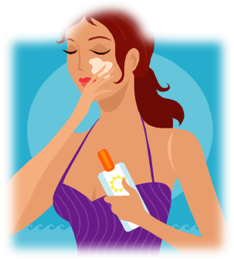

Everybody's Free (To Wear Sunscreen)
Baz Luhrmann
http://www.youtube.com/watch?v=sTJ7AzBIJoI

Task A
According to Baz
1.what should we do with our body?
………………………………………………………………………………………
2. why shouldn’t we read beauty magazines?
………………………………………………………………………………………
3. what are the ’certain inalienable truths’?
………………………………………………………………………………………

Task B
- Which future tense is used the most frequently in the lyrics?
……………………………………………………………………..
- Can you mention any prepositional verbs/phrasal verbs in the lyrics?
……………………………………………………………………...
- What synonyms of the word ’idle’do you know?
………………………………………………………………………
- Can you recall any sentences used in the ’as…as’ structure?
………………………………………………………………………
- Is the pronunciation of the narrator British or American? Can you tell examples to prove your idea?
……………………………………………………………………….

Task C
How do you interpret the meaning of ’sunscreen’ in the context of the song?
……...............................................................................................................................................................................
......................................................................................................................................................................................
How can the film be related to education?
......................................................................................................................................................................................

