Task Sheet - Video

Title of the video: What Kind Of Teacher Do You Want To Be?
Address: http://www.youtube.com/watch?v=nC-dkIh4i1Y&NR=1

Comprehension Questions
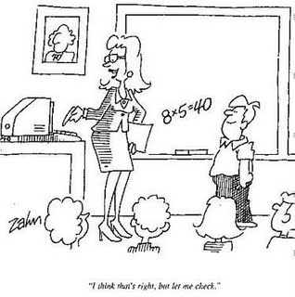
- Please write down as many aims the girls mentioned about influencing students’ learning process/attitude as you can.

- Why does the second girl (the one with glasses) consider laughter so important?

- Please collect the ideas (at least 4) that regard the social, pedagogical aspects of teaching.

Language Questions
- Please find several phrases with which the girls express their aims about teaching (e.g. I want to be…).

- How does one of the girls say the following: …who arouses the kids’ interest about…

- Find a synonym for the following: the kind of teacher who encourages students.

- Please find defining relative clauses in the clip (approximately 2-3).

- Finally, find an expression for the following: …to achieve the best she/he can…

Group Discussion
- What do you think about the girls’ opinion? Do you agree/disagree with them? Could you add some further pedagogical aims of your own? Please discuss the questions in groups of 3, then agree on the 3 most important pedagogical aims.

