Phonetics
Phonetics is the science of human speech sounds which are called phones. Phones are the minimal distinct sounds that we distinguish one after the other in the physical continuum of speech.
Phonetics has three subfields / branches.
- Articulatory phonetics: the study of the articulatory (vocal) organs and their role on the production of speech sounds.
- Acoustic phonetics: the study of the physical properties of speech sounds as they travel through the air in the form of sound waves.
- Auditory phonetics: the study of speech perception through the medium of the ear.
Phonetics only deals with speech sounds which do not include the sounds we produce when we sneeze, for example.
There are two main tasks of phonetics: (i) to provide a notation for each speech sound, and (ii) to provide a description for each speech sound.
(i) Notation
Notation: a system of transcription symbols by which a phonetician can make an accurate and unambiguous record of what goes on in speech.
Since the correspondence between letters and sounds is indirect (i.e. letters cannot do the job properly), we need a system of symbols to distinguish between the speech sounds. This is the International Phonetic Alphabet (= IPA). The transcription we do in phonetics is called narrow transcription; it’s a very detailed description of a sound (sometimes supplementary marks (= diacritics) are added), and it is enclosed in square brackets: [ ].
(ii) Description
Describing a speech sound happens in terms of phonetic features. In order to understand these features, we first have to get to know our articulatory organs shown in figure (1) below.
Figure 1
Human articulatory organs
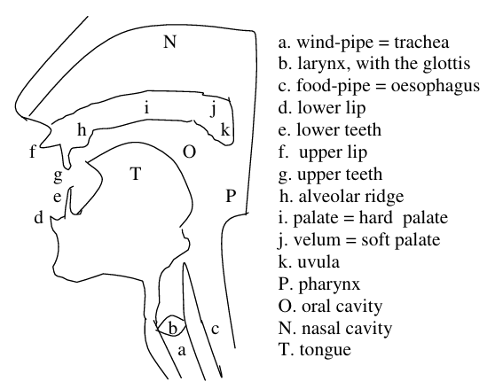
There are two characteristic features of speech sounds that we will look at here: (a) voicing and (b) nasality, and then we will look at place of articulation (c) and manner of articulation (d).
(a) Voicing
Voicing: the presence or absence of vocal cord/fold vibration during the production of a sound.
The vocal folds are found in the larynx (= “voice box”), and the opening which they can create is called the glottis. When the vocal folds are together and the air stream (coming from the lungs by way of the wind-pipe) passing through them makes them vibrate, the produced sound will be voiced [+voice]. When the vocal folds are apart and the air passes through them without any obstruction (i.e. without causing the folds to vibrate), the produced sound will be voiceless [–voice].
Voiced sounds: [b d g v ð z ʒ dʒ m n ŋ l r w j]
Voiceless sounds: [p t k f θ s ʃ tʃ h]
(b) Nasality
When the air leaves the glottis, it arrives at a cavity called the pharynx from which it can go on to two further cavities; the nasal cavity (in the nose) or the oral cavity (in the mouth). When the back of the velum (= the uvula) is raised, the passage of air through the nose is blocked, so these sounds will be oral [–nasal]. When the uvula is lowered, the air goes through the mouth and the nose, so these sounds will be nasal [+nasal]. When the latter happens, the air escapes exclusively through the nasal cavity.
Oral sounds: [p b t d k g f v θ ð s z ʃ ʒ h tʃ dʒ l r j w]
Nasal sounds: [m n ŋ]
(c) Place of Articulation
Place of articulation: the location inside the mouth at which the constriction of a sound takes place.
Most consonants are produced by using the tongue and other parts of the mouth to constrict (= restrict) the air that is passing through in order to create a sound. There are eight classes.
- Bilabials: using both lips.
  - [p b m w]
  - pat, bat, mat, way
- Labiodentals: using the upper teeth and the lower lip.
  - [f v]
  - fat, vat
- Dentals: using the tongue tip behind the upper front teeth.
  - [θ ð]
  - think, there
- Alveolars: using the front part of the tongue on the alveolar ridge.
  - [t d s z n l r]
  - top, dip, sit, zoo, nut, lap, right
- Palatoalveolars: using the postalveolar region
  - [ʃ ʒ tʃ dʒ]
  - shoe, pleasure, church, gem
- Palatals: using the tongue and the (hard) palate.
  - [j]
  - yet
- Velars: using the back of the tongue and the velum.
  - [k g ŋ]
  - kid, bag, bang
- Glottals: without the active use of the tongue and other parts of the mouth.
  - [h ʔ]
  - help, Scotland
(d) Manner of Articulation
Manner of articulation: the way a sound is produced. There are six classes.
- Stops / plosives: the air stream is stopped briefly then released abruptly.
  - [p b t d k g]
- Fricatives: the air stream is pushed through a very narrow opening.
  - [f v θ ð s z h]
- Affricates: the air stream is blocked briefly then released through a very narrow opening (think of it as a stop+fricative).
  - [tʃ dʒ]
- Nasals: the velum is lowered and the air stream is allowed to flow out through both the nose and the mouth.
  - [m n ŋ]
- Liquids: the air stream flows around the sides of the tongue as the tip of the tongue is raised to touch a part of the mouth.
  - [l r]
- Glides: the tongue is in motion (= gliding) while the air is passing through.
  - [w j]
(Sometimes liquids and glides are combined into one category called the “approximants).
The complete chart of English consonants can be found in figure (2) below.
Figure 2
English Consonants
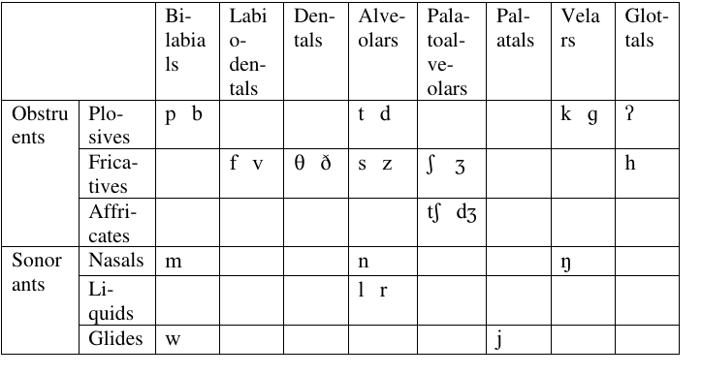
(iii) Vowels
So far, we have looked at consonants which are usually articulated via closure or obstruction in the vocal tract. Now, let us turn to the discussion of vowels.
Vowels are usually produced with a relatively free flow of air, and they are all typically voiced. You can produce different sounds with different positions (horizontal and vertical) of the tongue. There are eight “theoretical” vowels that are rather orientations points and can indicate the limits within which the tongue can move. These are called the cardinal vowels, and you can see the Cardinal Vowel Chart in (3).
Figure 3
Cardinal Vowel Chart
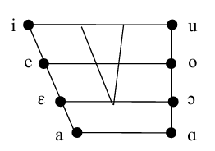
These vowels do not necessarily occur in every language.
Regarding English, there are 12 simple vowels, seen in (5). They are called simple vowels because the position of the tongue during the production of the sound is steady.
Figure 4
English Simple Vowels
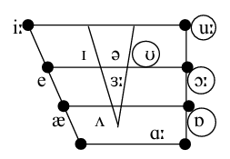
The vowels in the centre are called central vowels, those on the left of the triangle are front, those on the right of the triangle are back vowels. The ones encircled are produced with lip-rounding, these are round vowels. The ones that have a colon (:) after them are long vowels.
Front vowels: [i ɪ e æ]
beef, bid, bed, bad
Central vowels: [ə ʌ ɛ:]
support, blood, bird
Back vowels: [u ʊ ɔ ɑ]
move, book, caught, Bob
English has diphthongs as well. These are complex vowels where the tongue position is changed into another during the production but no new syllable is formed.
[aɪ] – eye
[aʊ] – doubt
[eɪ] – eight
[əʊ] – home
[ɔɪ] – noise
(iv) What Phonetics Deals with
Consonants and vowels together are called segments. Phonetics mainly deals with these segments; thus, a major part of phonetics is segmental phonetics. However, phonetics also has to deal with other aspects of human speech which are larger than just one segment. This is called suprasegmental phonetics which include intonation and stress.
- Intonation: the melody of an utterance.
- Stress: the extra prominence of a syllable over the other syllables in a word or phrase.

Homework
- (short reading from Study – Limitations of the chart, pp. 30–31.) What are the limitations of the consonant chart?
- (short reading from Study – Glottal stops and flaps, p. 33.) When does a glottal stop occur? Can you list some words in which a glottal stop occurs?
  - What is flapping? can you list some words in which flapping occurs?
- ICEL (p. 46) – exx, 2, 3, 4

