MEDIEVAL THEATRE
Handout by Natália Pikli, PhD

TYPES
- Mystery plays (biblical scenes, Christ, divine mystery, re-enactment), also called miracle plays in England
The Building of the Ark, Crucifixion

- Morality Plays (interludes, Virtues and Vices, Everyman/Youth, psychomachia), everywhere in Europe
Everyman, The Castle of Perseverence

- Miracle plays (saints’ lives, focussing on miracles), mostly in France

ORIGINS OF MEDIEVAL DRAMA
1.) THE CHURCH/ RELIGION
- Divine mystery (cf. Greek drama, Dionysos), holy day – holiday (Eliade: sacred and profane)

- Easter tropes: ‘Quem quaeritis?’ (Christ’s tomb: Angel and the 3 Marys) – later: additional dialogue, props, set, SD, costumes) – out into the (church)yard

- Liturgical drama: in Latin, sacred music, clergymen

- Similarly: Christmas tropes (nativity, shepherds) and Twelfth Night (Magi, star)

2.) FOLK RITUALS/ DRAMATIC RITUALS/ CARNIVALESQUE FESTIVITIES,
cf. Bakhtin
- Secular drama: in English, folk muisc, dance, amateur players)
- The Battle of Carnival and Lent
- Christmas mummings (miming, music, dance, sword fighting, death and revival)
- St. George plays
- Harvest festivals, wedding playlets, etc.

PERFORMANCES OF MYSTERY PLAYS
- The Feast of Corpus Christi
- Christ’s redemptive power through the miracle of the Host (procession of the ‘holy body’)
- 1264, Pope Urban, popular from 14th c.
- 23 May-24 June
- The whole town taking part (audience, players, etc.) – collective experience

PAGEANT WAGONS
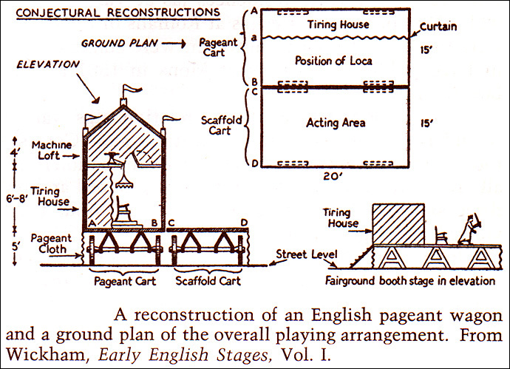

- Pageant wagons (moving through the town or at the main square in a circle) or set scaffolds – each for one scene
- ’epic theatre’ – ‘the whole story’, focus on Christ
- Trade fairs – trade guilds (advertising, showing the skill, devotion)
- Elaborate set and props, effects, hellmouth, thunder, etc.
- Mystery and mastery (amateurism)
CYCLES
- Chester cycle – 25 episodes
- York cycle – 48 episodes
- Coventry/N-town cycle – 42 episodes
- Wakefield/Towneley cycle – 32 episodes, 6 by the Wakefield Master (fl. 1475)
- Disappearance of mystery plays: 16th c. – new genres, Henry VIII, ‘popish’, last Wakefield perf. 1576 (The Theatre in London, professional actors)

