Dear Christopher
[…]
I teach at an elementary school in Isaszeg. I'm a substitute teacher with a contract expiring at the end of this June. I started teaching roughly a month ago and got all 5 classes of my predecessor. Three of the classes are a joy to be with, one is testing my limits behaviour-wise, but the fifth is a total disaster. They are a bunch (20) of "difficult" kids, with very disadvantaged backgrounds (parents in prison, parents committing suicide, mom walking out on the kids a few years back, you got the picture). They are the gangsters of the school, all the teachers are afraid of them (professionally), their previous English teacher (and osztályfonök) is down with a nervous breakdown because of them.
I started out in a relaxed, easy-going way, worked fine for the first week or so. I tried bringing them interesting stuff, they couldn't care less. I played team-building games with them, which went down well but we spoke Hungarian. This week they've been so unruly that I lost my patience and gave out 4 "szaktanári figyelmeztetés". I guess I lost all the trust I had managed to build up up to that point. Sigh. And I'm totally at a loss about what to do next.
At the same time I'm even more disappointed in our school system than I ever was before. I feel for these kids who have been let down by the system and us teachers from the start. I'm disgusted when I hear day-after-day how teachers talk down at kids, how they humiliate them with every single word they utter. Yuck.
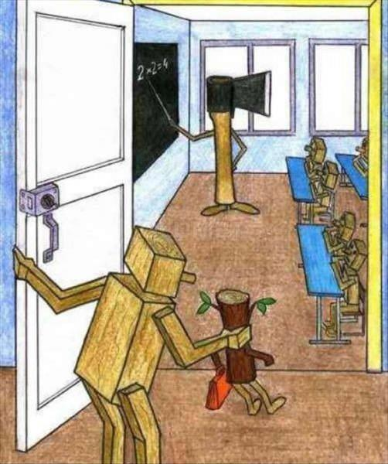
I would love to set up an open classroom kind of arrangement in the long run, but I don"t think the time has come yet, I'll wait until my contract is renewed and I have a solid status. I've thought of apologizing to them and initiating a conversation about schools and their feelings about schools.
I'd print some cartoons like this as conversation starters:
I'd then try to agree on some kind of code or contract. All these sound great on "paper" but I have my doubts on how they would respond to an approach like this. What do you think? Have you got any ideas I didn't think of?
[…]
Barbara

