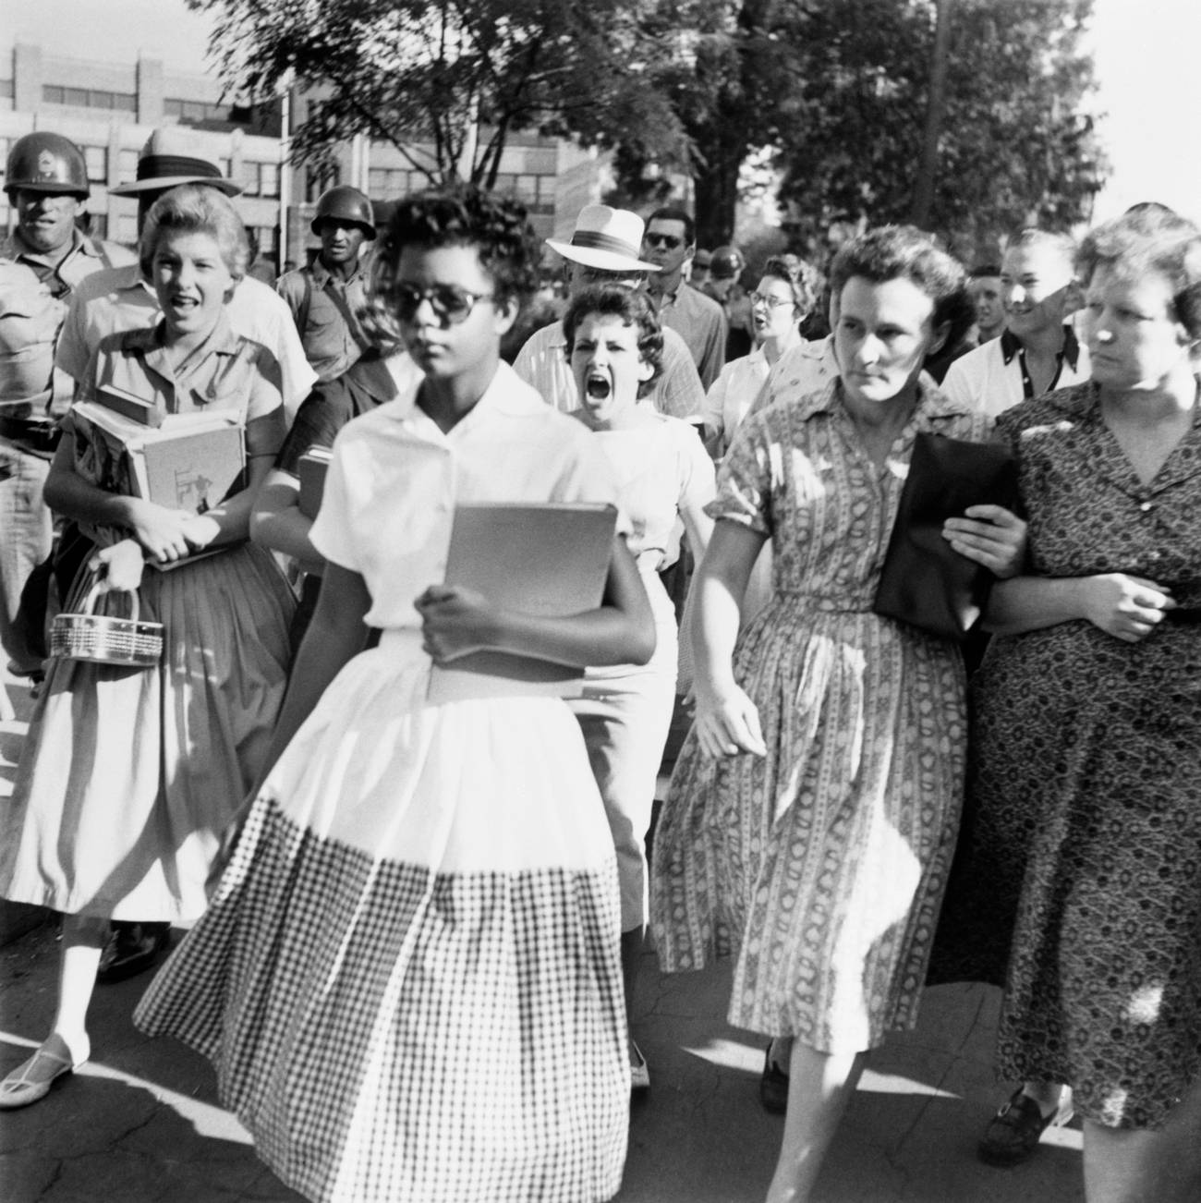

from RESPONSIBILITY AND JUDGMENT “Reflections on Little Rock” pp. 193-213
- What was her first question? What was her answer?
- What is the difference between a “social” and a “political” predicament? (you may also TRY to understand Arendt’s distinction between the social and the political: https://plato.stanford.edu/entries/arendt/)
- What is pride? What’s the reason why pride is not a political question, according to Arendt?
- What is her argument about adults and children?
- What are the “real issues”? What is the difference between “real issues” and “social climbing”? (This is a difficult question; just make an attempt to answer it.)
- What is her argument about white mothers? (what is the argument about the freedom to chose one’s “company” and what’s the reason why it does not go against the principle of political equality – the real issue)
- Why is the right of citizens to marry whoever they wish different from enforced school integration?
- Explain: “Not discrimination and social segregation, in whatever forms, but racial legislation constitutes the perpetuation of the original crime in this country's history.”
- What is the one “great crime” in America’s history and who are responsible for it?
- Why is the “visibility” of the “Negroes”… a political question? (What does she say about the appearance of “inner qualities”?)
- Explain the VERY controversial claim that: “It is therefore quite possible that the achievement of social, economic, and educational equality for the Negro may sharpen the color problem in this country instead of assuaging it’
- What is the difference between social custom and legal enforcement (of segregation)? (202)
- In the first paragraph of p. 203. Arendt establishes a hierarchy of rights – what is the rationale behind this hierarchy?
- Explain: “Segregation is discrimination enforced by law, and desegregation can do no more than abolish the laws enforcing discrimination; it cannot abolish discrimination and force equality upon society, but it can, and indeed must, enforce equality within the body politic. For equality not only has its origin in the body politic; its validity is clearly restricted to the political realm. Only there are we all equals.”
- Explain: “Strictly speaking, the franchise and eligibility for office are the only political rights, and they constitute in a modern democracy the very quintessence of citizenship. In contrast to all other rights, civil or human, they cannot be granted to resident aliens. What equality is to the body politic-its innermost principle discrimination is to society. Society is that curious, somewhat hybrid realm between the political and the private in which, since the beginning of the modern age, most men have spent the greater part of their lives. For each time we leave the protective four walls of our private homes and cross over the threshold into the public world, we enter first, not the political realm of equality, but the social sphere. We are driven into this sphere by the need to earn a living or attracted by the desire to follow our vocation or enticed by the pleasure of company, and once we have entered it, we become subject to the old adage of "like attracts like" which controls the whole realm of society in the innumerable variety of its groups and associations. What matters here is not personal distinction but the differences by which people belong to certain groups whose very identifiability demands that they discriminate against other groups in the same domain. […]without discrimination of some sort, society would simply cease to exist and very important possibilities of free association and group formation would disappear. […] In any event, discrimination is as indispensable a social right as equality is a political right. The question is not how to abolish discrimination, but how to keep it confined within the social sphere, where it is legitimate, and prevent its trespassing on the political and the personal sphere, where it is destructive.”
- What is the difference between choosing where and with whom one spends one’s vacation and choosing next to whom one sits on a bus? How about the private sphere of marriage?
- Explain Arendt’s stance about schooling being a social rather than a public affair based on pp. 210- 213.

