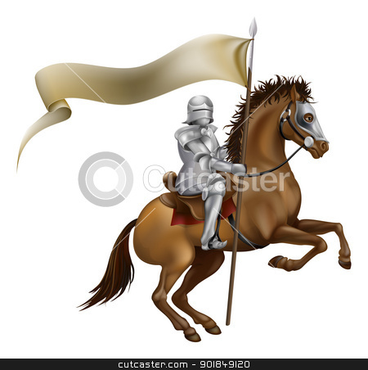
Cultures of Europe:
THE AGE OF CHIVALRY (c. 5th c.- 15th c.)
(Lesson 2- 15 th October 2012)

Summary of previous lesson: The heritage of Ancient Greece and Rome
literature (heroism –Achilles, intellect – Odysseus),
history (democracy and empire), science (mathematics, medicine, etc.),
values: Greek – educated men, Rome - bravery and nobility

HISTORICAL OUTLINE OF THE MIDDLE AGES:

- Fall of the Western Roman Empire
- ’Dark ages’ of Migration: different peoples come and occupy today’s Europe: Germanic tribes, Goths, Hungarians, etc. + "Dark Ages", a characterization highlighting the relative scarcity of literary and cultural output from this time, especially in Western Europe.(no books, manuscripts etc.)
- Rise of Christian kingdoms – crusades
- the Black Death (plague)

- MIDDLE AGES: THE ROLE OF RELIGION (preserving culture)

- LATIN is the common language of the educated
  - Christianity everywhere, on all levels of life (incorporating or destroying Pagan customs (cf. Christmas – 25th Dec. – birth of Christ = midwinter solstice /the longest night/, Yuletide)
  - Bible – Christianity – not heroism but self-sacrice and suffering (Jesus on the cross died to save mankind – the crucifix).
  - Love, hope, tolerance. Jesus – Son of God and Son of Man (Virgin Mary)

The Medieval view of the world: - the soul never dies, the body dies only
Heavens – lasting forever, eternal bliss
(Middle-)Earth/our world – it is transitory (not lasting), a place of suffering and test,our journey on this earth: darkness, sickness, etc.
Hell – eternal suffering

The Last Judgment (when the world comes to an end)
Dies irea (Tomas Celano, 13th c., Latin hymn, MUSIC- HARMONY: Gregorian chant)- The Day of Wrath (Anger)

The Great Chain of Beings: set hierarchy, every being has a fixed place on the ’ladder’ : at the top - God, in the middle – human beings , at the bottom – beasts and soulless plants, stones, etc.

Styles in Architecture:
CATHEDRALS- symbols of the age
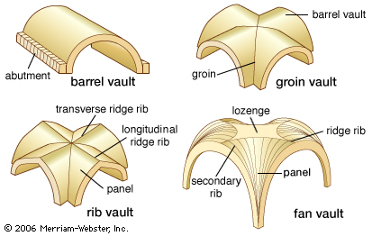
Romanesque – massive quality, thick walls, round arches, sturdy piers, groin vaults, large towers and decorative arcading.

Gothic - emergence of a new building style. Those technologies were the pointed arch, the ribbed vault, and the flying buttress-focusing on verticality and light.

MONASTERIES: monks copying and protecting not only biblical texts but also ancient knowledge in libraries

Beowulf (England, 6th-10th century)-video

II. SECULAR CULTURE: CHIVALRY
- historical background: constant warfare: kingdoms fighting each other , eg. ’The Hundred Years War’ between France and England + the Crusades (’holy’ warfare against Muslims, to regain the Holy Land of Christ, Jerusalem)

Code/ideals of a Christian knight:→ stories of King Arthur and the Knights of the Round Table
- believes in God, fights in his name
- a brave warrior
- gallant to women (courtly love)
- quest (mission)

III. GROTESQUE – HUMOUR of the folk, of the penniless

The Canterbury Tales is a collection of stories written in Middle English by Geoffrey Chaucer at the end of the 14th century. The tales (mostly written in verse although some are in prose) are presented as part of a story-telling contest by a group of pilgrims as they travel together on a journey from Southwark to the shrine of Saint Thomas Becket at Canterbury Cathedral. The prize for this contest is a free meal at the Tabard Inn at Southwark on their return.
He uses the tales and the descriptions of its characters to paint an ironic and critical portrait of English society at the time, and particularly of the Church.
Carmina Burana – a collection of bawdy and indecent but very entertaining songs of medieval students
Francois Villon (15th c. France) – a university student (Sorbonne), a thief, a poet
Quatrain In Expectation of His Execution
I'M Francis ill avails it me
Born near Pontoise, in Paris see :
Whose neck, at the end of a rope of three,
Must feel how heavy my buttocks be.

Homework → Match the highlighted words from the handout with their definitions:

courtly love to highlight scarcity literary (output) cultural(output)

eternal transitory stage jousts gallant (to women) monastries

romanesque style gothic style nobility Last Judgment to preserve

self-sacrifice to suffer/ suffering to tolerate/ tolerance

1) An idealized form of love in which a knight or courtier devotes himself to a noblewoman who is usually married and feigns indifference to preserve her reputation.

2) to experience physical or mental pain

3) (in the past) to fight with a lance (= a long pointed weapon) while riding on a horse

4) to attract attention to or emphasize something important

5) when something is not easy to find or get

6) honesty, bravery and unselfishness

7) style of building which has pointed arches and windows, high ceilings and tall, thin columns

8) giving up what you want so that other people can have what they want

9) connected with literature

10) showing no fear of dangerous or difficult things

11) The final judgment by God of all humankind, as envisioned in Christian, Jewish, and Islamic scriptures.

12) lasting forever or for a very long time

13) a building in which monks live and worship

14) lasting for a short time, after which something will come or happen.

15) to accept behaviour and beliefs which are different from your own

16) to keep something as it is,in order to prevent it from decaying or being damagd/destroyed

17) characterized by massive walls, round arches, and relatively simple ornamentation.
18) relating to the habits, traditions, beliefs and culture of a society.

